**Difficulties we faced and how we solved them:**

1. We were not very familiar with standardization and normalization and ended up having very strange results because of less-than-ideal normalization methods
   1. We talked to Professor Rajesh Kumar about the possible ways to apply min-max and standard scaling technique as well as the various statistical implications that these techniques would have in different contexts. Finally, we decided to accept the one which loses the least amount of information.
2. We had some discrepancies in the way we used NumPy packages (compared to how we used the packages back in Lab 2). These resulted in code which was not exactly reusable. We only found out about it when we were debugging our code. We realized that instead of getting arrays we were getting scalar values.
   1. Instead of trying to patch the flaws, we redid the code so that our code would perform just as expected. We figured that it would be a lot more effective if we were to redesign how we used the numpy and scipy packages.

Figure 1: ROC for statistical vectors compared with pointwise distance (User 1)

Figure 2: DET for statistical vectors compared with pointwise distance (User 1)

Figure 3: Histogram for statistical vectors compared with pointwise distance (User 1)

Figure 4: Histogram for statistical vectors compared with histogram method(User 1)

By comparing the statistic, frequency, and stat-freq vectors with the different comparison schemes (pointwise distance, dtw, and histogram), we were able to see some objective and subjective advantages that some of these methods had for different users. As shown in Figure 4, the histogram method is objectively the worst. Because of the way data is binned, precious information is lost, resulting in a huge deviation from what is termed as a perfect ROC/DET curve (shown in Figure 1 and 2). The thresholds are hardly helpful for them because of how data has been amassed into chunks which limits the use of thresholds which are far more discrete than what histograms can offer.

Figure 5: Statistical vectors for Gen-Train in User 1

Figure 6: Frequency vectors for Gen-Train in User 1

Figure 7: Stat-freq vectors for Gen-Train in User 1

We built our statistic vectors around the following metrics:

1. Minimum
2. Maximum
3. Mean
4. Standard Deviation
5. 25th Percentile
6. 50th Percentile
7. 75th Percentile
8. Max Peak
9. Kurtosis
10. Skew

We built our frequency vectors around the following metrics:

1. Minimum
2. Maximum
3. 5th Percentile
4. 25th Percentile
5. 50th Percentile
6. 75th Percentile
7. 95th Percentile
8. Mean
9. Standard Deviation
10. Max-Min Ratio

The stat-freq vectors is a concatenation of the statistic and frequency vectors.

Even though statistic, frequency, and stat-freq vectors offer different types of information about the sliding windows, stat-freq vectors offer the most balanced information about the waves. Because of how the statistic vectors and frequency vectors contain different information about the waves, they tend to perform for the better or the worse depending on the nature of the waves. The stat-freq vectors contain information from the different domains. Comparing the stat-freq vectors gives equal weight to factors from both domains and reduces the problem of biased comparisons.

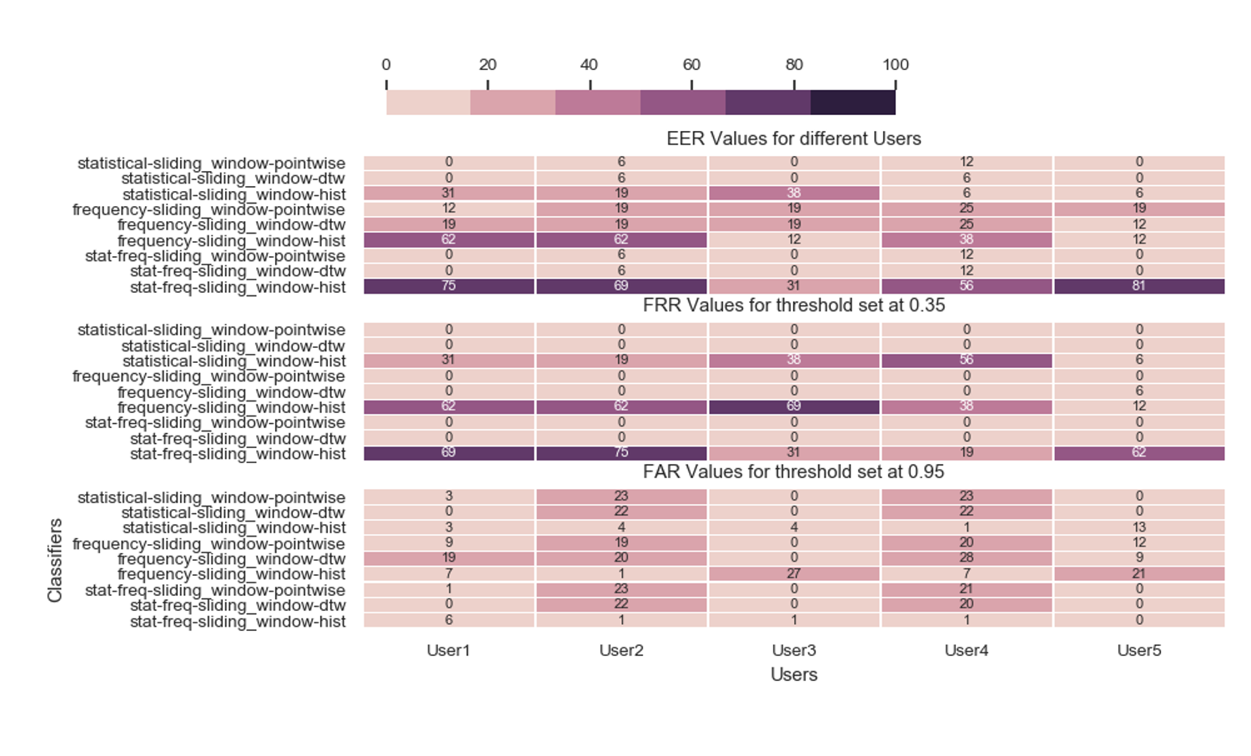

Figure 8: Heat Map for Lab 3

As shown in Figure 8, we have developed 3 set of metrics to determine the suitability of the different biometric setup: EER, FRR for threshold value of 0.35, and FAR for threshold value of 0.95.

For the EER, it is clear that the histogram intersection method is by and large the inferior method. In fact, this is true not only for EER but for most metrics. As mentioned above, the histogram intersection method uses binning and this results in a loss of information that makes the results of the evaluation far less reliable. It not only frequently results in a large distance between that and the genuine value but also occasionally creates the illusion that the method performs better than other methods (as seen from how User 3 has a lower frequency-histogram value than frequency-pointwise). Nonetheless, it is still certain that pointwise and dtw have a far better performance than histogram intersection. Also, it is worth noting how stat-freq values seem to be a result of their respective stat and freq vector distances. This matches our understanding of how distances are calculated and how the stat-freq vectors are built from their stat and freq vectors. User 1, 3, and 5 would have a near perfect EER values for systems that are not using freq as their vectors.

For the FRR for threshold value of 0.35, it is designed to recommend low security options for the different users. Because low security options often imply some sort of need for a higher True Acceptance Rate, a high FRR would defeat the purpose of a low security option. Based on the data in Figure 8, the FRR for all users are practically zero at the threshold level of 0.35. Other than the high values generated by the histogram method (which are flawed by nature due to the loss of information), the existing system would fulfill the low security needs of any client.

For the FAR for threshold value of 0.95, it is designed to recommend high security options for the different users. Because high security options often imply some sort of need for a higher True Rejection Rate, a high FAR would defeat the purpose of a high security option. Based on the data in Figure 8, the system would suit User 1, 3, and 5. The FAR is significantly higher for Users 2 and 4. Similarly, the histogram method is outperforming the dtw and pointwise methods only because it bins most of its upper values together.